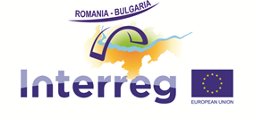

Thematic meeting with the Lead beneficiaries of the projects financed under the third call of INTERREG V-A Romania – Bulgaria Programme

26th of October 2018, Silistra, Bulgaria

Hall of „Danube“ Hotel (Red saloon),

1 "Svoboda" Square

AGENDA
10:00 – 10:30 Registration of participants
10:30 - 11:30 Request for FLC - Reporting in e-MS system – Procedures to be followed
11:30 - 12:00 Contract modifications - Procedures to be followed
12:00 – 13:00 Open disscussions, Best practices, Questions and answers
13:00–13:30 Lunch break
13:30-14:00 Info and publicity measures
14:00-14:15 Antifraud and conflict of interests
14:15 – 14:30 Communication at the project level
14:30 – 15:00 Open disscussions, Best practices, Questions and answers
15:00 – Closure of the meeting

