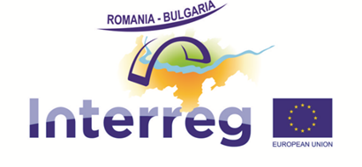

CITIZEN'S SUMMARY
of the Annual Implementation Report for 2017 regarding the
Romania-Bulgaria Interreg V-A Programme

Programme implementation status in 2017: full speed!

84 projects (102 million euro ERDF) under implementation, 5 already finalized, a lot of results.

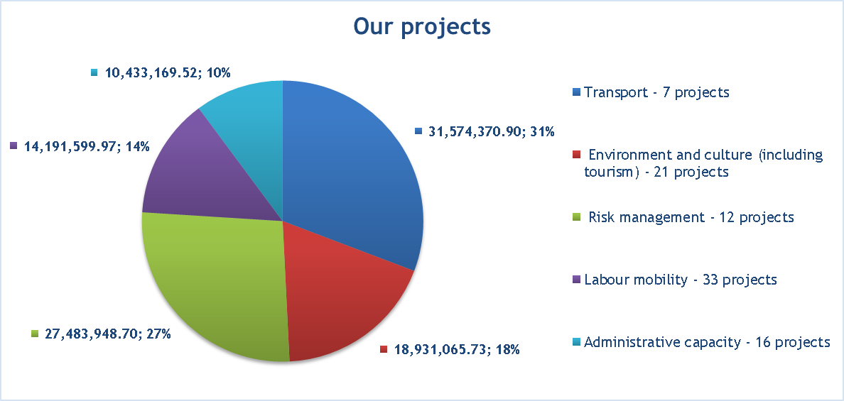
These projects are dedicated to modernization of road infrastructure and transport safety measures, promotion of natural and cultural heritage (including tourism), risk management, developing labour mobility and increasing administrative capacity.

Results!
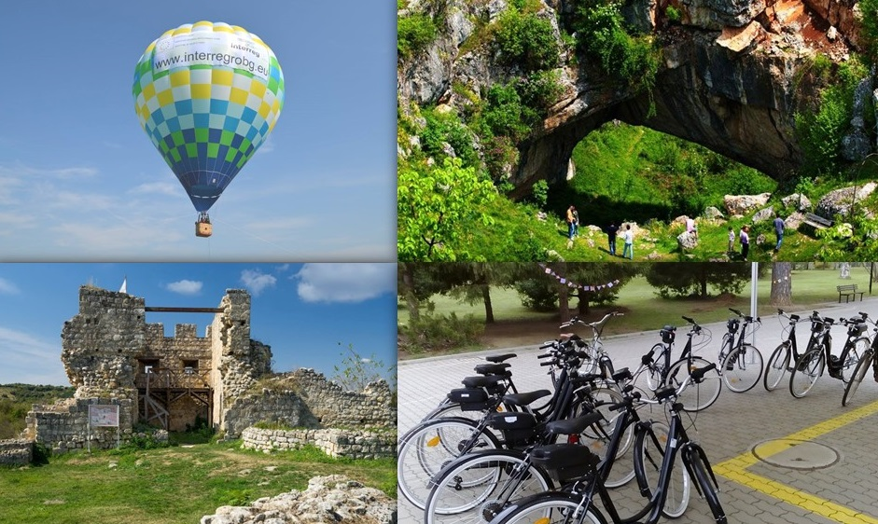
- A network of charging stations and electrical bicycles available within the entire eligible area. The electrical bicycles are available to the large public for rent, free of charge or with very low costs, at different operators located within the municipalities and counties in the Romania-Bulgaria area (maximum 70 km one from each other) allowing the people in the area a great mobility and facilitating the access of population and tourists to cultural and historical sites. More information at: http://danube-ebike.net.
- A preliminary study on intermodal nodes’ current state and their capability to enhance the TEN-T network within the CBC area which will further on be developed within a common strategy on TEN-T network enhancement through improving intermodal nodes’ capacity was drafted.
- New joint tourist products were created to promote the natural and cultural heritage in the border area. These products include 2 hot-air balloons that fly over both countries (more information at: http://balloonadventure.eu/en/), a travel guide with 6 joint routes, promoted by 6 promotion movies (more information at http://mehedinti-vidin.ro/en/); a catalogue of protected areas and a promotional film of the area (more information at: http://prunepentrugunoi.ro/video); authentic tradition festivals for promoting cultural traditions and touristic products in the eligible area (more information at www.robgtraditions.com); 16 Roman sites from the cross-border area digitalized and more models of artefacts and objects printed in 3D format and included in permanent exhibitions at the headquarters of the project partners (https://www.romanforts.eu). Also, a new one integrated product named Green School Education was developed on the territory of Montana district and Dolj county (http://greenschooleducation.eu), including the establishment of an Tourist Information Center in Craiova (https://www.facebook.com/greenschooleducation/).
Contribution to Programme indicators!

- 1 joint mechanisms improving transport in the eligible area was established: a network of charging stations and electrical bicycles
- 20 new integrated tourism products/services were created:
  - 3D models of attractive historical sites
  - audio guides
  - GPS navigation apps including touristic attraction info
- 6 plans for valorizing the cultural and natural heritage were created
- Number of visits to supported sites of cultural and natural heritage and attractions: increased with 7600 per year!
- 12.5 hectares from the habitats supported attained a better conservation status (we developed strategies and better management plans for 4 Natura 2000 sites)
- 6018 people benefited of risk management actions (2 studies, 12 movies and 3 books, as well as trainings and conferences were done on Large Scale Risks)
- 6 initiatives to activate the workforce mobility in the cross border area were established
- 116 people participated in joint employment and training initiatives (legal mobility in the juridical field (RoBg 162), measures for support of employment of women, youth, disadvantaged people (RoBg 143, 163), establishment of cross border training centers (RoBg 147), creation of incubators for promotion of employment, labor mobility in the field of tourism, organic agriculture, construction, wine industry, local artisans)
- 1 mechanisms to enhance cooperation capacity was established (in health domain, Dolj and Vratsa region).

Who benefits?
The entire population within the eligible area of the programme, all counties and districts are already benefiting of the tangible results of our projects.
The bicycle network is the most visible and accessible result of the Programme in 2017. In fact every person with the eligible area has access to the bicycles and can use them for day to day travel to the work place, visits to cities or objectives on the other of the border. Also, the projects related with tourism and promotion of the cultural and natural heritage of the area will benefit to the business in the area, hotels, guest houses and to the establishments administrating the touristic objectives (museums, public administrations, etc.). The preliminary study on intermodal nodes’ current state and their capability to enhance the TEN-T network within the CBC area which will be further developed by a common strategy on TEN-T network enhancement through improving intermodal nodes’ capacity will be of benefit to the entire population in the eligible area.
Keep an eye on us, this is just the beginning!
The Programme is very active on promoting its results and projects. So, for each project under implementation, a short fact sheet presentation is available on the Programme website. The page is permanently updated with new information on the project status implementation. We are inviting you to check all our projects on http://interregrobg.eu.
At the end on 2017 the Programme has initiated a promotion campaign of the first project results through short movies and photos. 6 great projects were selected to participate to this campaign which will be promoted on the program Facebook page (https://www.facebook.com/RomaniaBulgariaCbcProgramme?fref=ts) starting with January 2018.
http://interregrobg.eu
https://www.facebook.com/RomaniaBulgariaCbcProgramme?fref=ts
https://twitter.com/ROBGProgramme
https://www.youtube.com/channel/UCtgRgCcdOK5D2ZsBJrMPXew/videos
https://www.instagram.com/interregrobg/

